Product Manual

Name：Bluetooth Warm and Cool White LED Ceiling Light V1.0
Model：ZJ-CL-CW V1.0
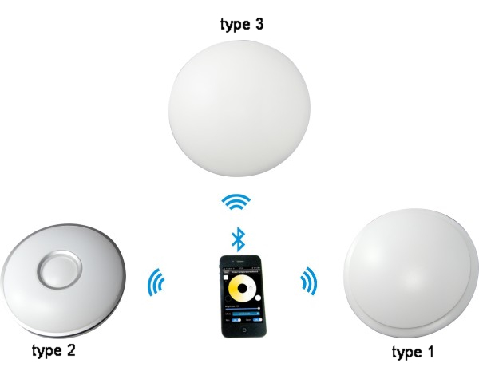

I. Product Summarize
This ceiling light support Bluetooth version 4.0 or above.
It can achieve remote control,switch light,adjust brightness and color temperature.Adjusted light modes according to common light distribution,it owns a lot of modes.In addition, it do not need additional line,conveniently installed and used.
It is a high capability and easily replaceable LED ceiling light.Certainly,it have other advantages,such as light source is LED,power consumption is just 20% of traditional incandescent,working life is 10 times of traditional save-power light,safe and stable.
The case adopts aluminum fins,which can let air backflow cyclically.This design resolved high-powered LED thermal problems in highest degree. Ceiling light is made of graced poly materials with high transmitacnce 85% or above,and luminous is uniformity.It controlled by wireless Bluetooth,furthest remoted distance catch up to 60m.It enjoys low power-consumption ,great anti-jam capacibity,high transmission speed.It can keep light memory(when restart,it will auto keep previous status before shutdown). In addition ,it will turn on in default when energized.This function avoid this situation that you cann’t turn on light when phone were lost.
It can be used widely in bedroom ,galley,vestibule etc.

II.Technical Parameter:

Conection Methods | Bluetooth Version 4.0
Suitable Phone OS | Any OS support Bluetooth version 4.0 or above
Software language | English
Channels | 2（Warm White and Cool White）
Chips Specification | Warm white:SMD 5730*24  Cool White：SMD 5730*24
Light Luminous Flux(PCS) | Warm White:40-60LM  Cool White: 40-60LM
Color Temperature | Warm White: 2700K-3000K  Cool White: 5500K-6500K
Emitting Angle | Warm White: 140°  Cool White: 140°
Working Voltage | AC100V-AC240V 50/60Hz
Power | ≤21W
Working Temperature | -30℃-55℃
Effective Romoted Distance | No barrier,60m ;Indoor, 30m
Light Material | Milk white PMMA
N.W | Type 1: ≤710g  Type 2: ≤735g  Type 3: ≤730g
G.W | Type 1: ≤1260g  Type 2: ≤1290g  Type 3: ≤1280g
Waterproof | IP 25
Light Size | Type 1(D:355mm; H:100mm)  Type 2(D:345 mm; H:85mm)  Type 3(D:375mm; H:97mm)

Ⅲ. Spectrum Light Distribution Curve(each pcs)

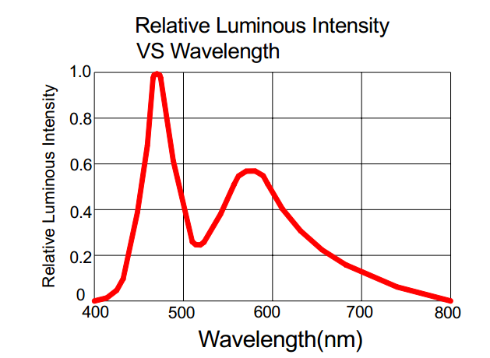

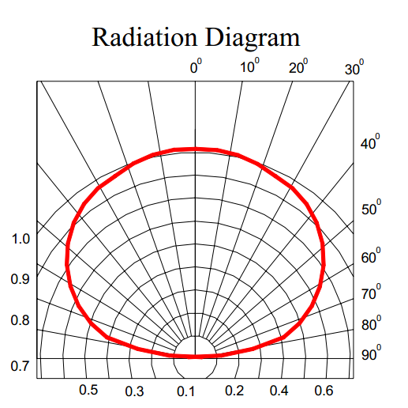

*****************************************************************************************************************************
Warranty Time:

2 years(include scond year).Any problem caused by quality,we will provide free maintenance.

Remarks:

1.Pls don’t operate it when energized.
2.Pls don’t use it in areas which are full of metal and strong electromagnetic waves.Otherwise,effective remoted distance will be shortened significantly.

Notice:

1.Thanks for using our product .Pls read our product specification manual.When you use it ,it means that you have read our manual defaultly.
2.Our company have the right of exlanation and modification of all files equipped.Sorry for that we will not give you additional notice if there were many modifications.

